# SQL QUERY FOR 5

## SESSION FROM 5:

### 5.1:

**LIMITATIONS OF IMPLICIT CURSOR:**

* Without a where clause it causes error

DECLARE

v_salary employee3.salary%TYPE;

BEGIN

SELECT salary INTO v_salary

FROM employee3;

DBMS_OUTPUT.PUT_LINE('salary is: '||v_salary);

END;

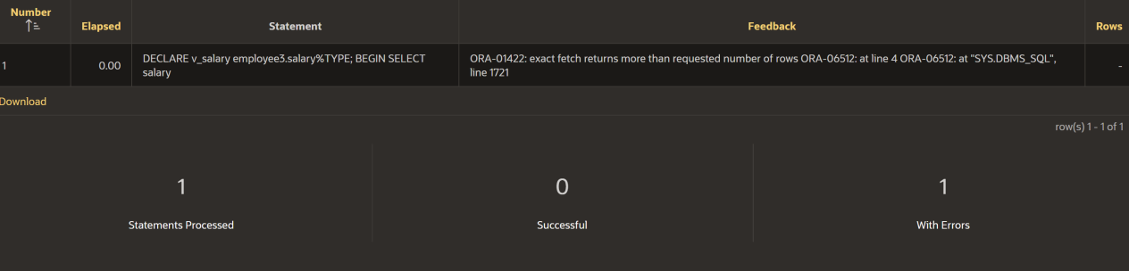

* **EXPLICIT CURSOR:**

**TABLE:**

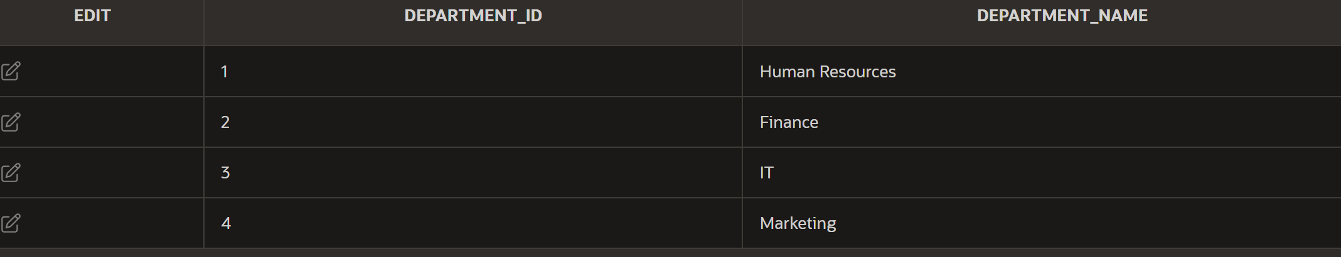

DECLARE

CURSOR cur_depts IS

SELECT department_id, department_name

FROM departments;

v_department_id departments.department_id%TYPE;

v_department_name departments.department_name%TYPE;

BEGIN

OPEN cur_depts;

LOOP

FETCH cur_depts INTO v_department_id, v_department_name;

EXIT WHEN cur_depts%NOTFOUND;

DBMS_OUTPUT.PUT_LINE(v_department_id || ' ' || v_department_name);

END LOOP;

CLOSE cur_depts;

END;

**OUTPUT:**

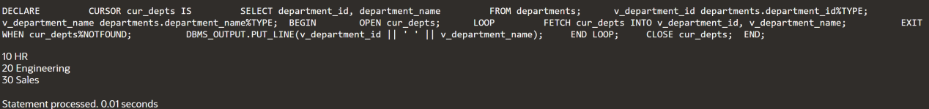

**FETCHING DATA FROM THE CURSOR:**

**TABLE:**

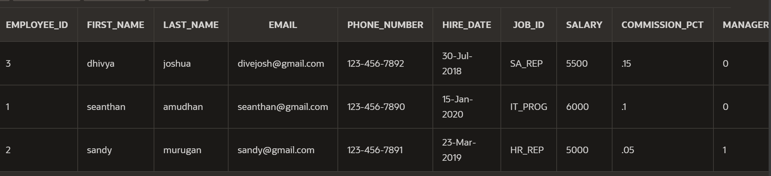

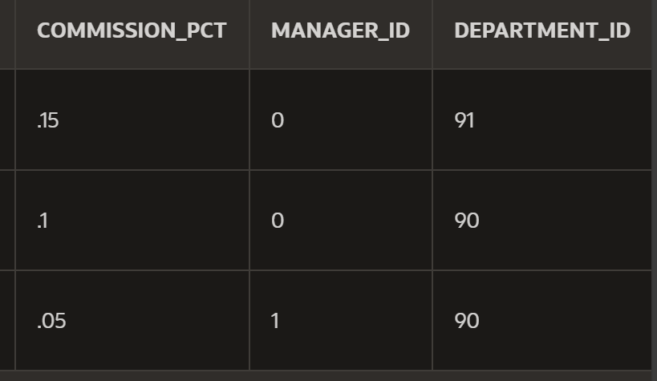

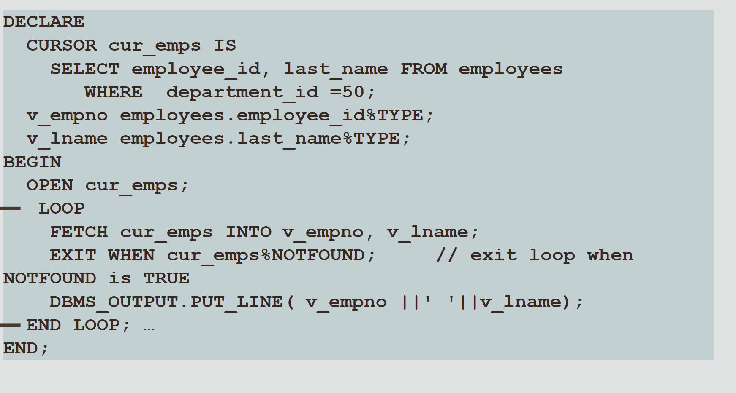

**OUTPUT:**

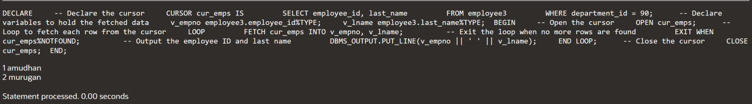

P**UTTING IT ALL TOGETHER:**

**TABLE:**



DECLARE

CURSOR cur_depts IS

SELECT department_id, department_name

FROM department1;

v_department_id department1.department_id%TYPE;

v_department_name department1.department_name%TYPE;

BEGIN

OPEN cur_depts;

LOOP

FETCH cur_depts INTO v_department_id, v_department_name;

EXIT WHEN cur_depts%NOTFOUND;

DBMS_OUTPUT.PUT_LINE(v_department_id || ' ' || v_department_name);

END LOOP;

CLOSE cur_depts;

END;

**OUTPUT:**

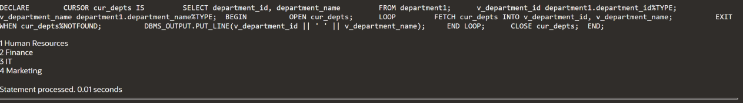

### 5.2:

**CURSOR AND %ROW:**

**TABLE:**





DECLARE

CURSOR cur_emps IS

SELECT * FROM employee3 WHERE department_id = 90;

v_emp_record cur_emps%ROWTYPE;

BEGIN

OPEN cur_emps;

LOOP

FETCH cur_emps INTO v_emp_record;

EXIT WHEN cur_emps%NOTFOUND;

DBMS_OUTPUT.PUT_LINE(v_emp_record.employee_id || ' ' || v_emp_record.last_name);

END LOOP;

CLOSE cur_emps;

END;

**OUTPUT:**



**%ROWCOUNT AND %NOTFOUND:**

**TABLE:**





DECLARE

CURSOR cur_emps IS

SELECT employee_id, last_name

FROM employees;

v_emp_record cur_emps%ROWTYPE;

BEGIN

OPEN cur_emps;

LOOP

FETCH cur_emps INTO v_emp_record;

EXIT WHEN cur_emps%NOTFOUND OR cur_emps%ROWCOUNT > 10;

DBMS_OUTPUT.PUT_LINE(v_emp_record.employee_id || ' ' || v_emp_record.last_name);

END LOOP;

CLOSE cur_emps;

END;

**OUTPUT:**

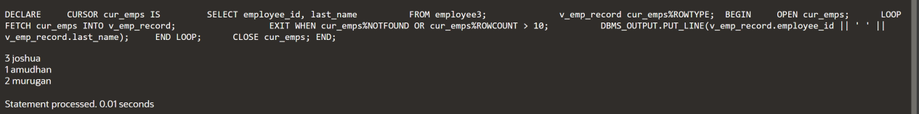

### 5.3:

**CURSOR FOR LOOPS:**

**TABLE:**





DECLARE

CURSOR cur_emps IS

SELECT employee_id, last_name

FROM employee3

WHERE department_id = 91;

BEGIN

FOR v_emp_record IN cur_emps LOOP

DBMS_OUTPUT.PUT_LINE(v_emp_record.employee_id || ' ' || v_emp_record.last_name);

END LOOP;

END;

**OUTPUT:**



### 5.4:

**CURSOR WITH PARAMETERS:**

**TABLE:**





DECLARE

v_deptid employee3.department_id%TYPE;

CURSOR cur_emps (p_deptid NUMBER) IS

SELECT employee_id, salary

FROM employee3

WHERE department_id = p_deptid;

v_emp_rec cur_emps%ROWTYPE;

BEGIN

SELECT MAX(department_id) INTO v_deptid FROM employee3;

OPEN cur_emps(v_deptid);

LOOP

FETCH cur_emps INTO v_emp_rec;

EXIT WHEN cur_emps%NOTFOUND;

DBMS_OUTPUT.PUT_LINE(v_emp_rec.employee_id || ' ' || v_emp_rec.salary);

END LOOP;

CLOSE cur_emps;

END;

**OUTPUT:**

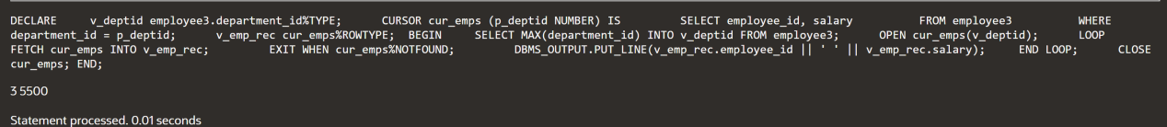

## 5.5:

**NOWAIT,UPDATE AND WHERE CURRENT OF CLAUSE:**

**TABLE:**





DECLARE

CURSOR cur_emps IS

SELECT employee_id, salary

FROM employee3

WHERE salary <= 20000

FOR UPDATE NOWAIT;

v_emp_rec cur_emps%ROWTYPE;

BEGIN

OPEN cur_emps;

LOOP

FETCH cur_emps INTO v_emp_rec;

EXIT WHEN cur_emps%NOTFOUND;

UPDATE employee3

SET salary = v_emp_rec.salary * 1.1

WHERE CURRENT OF cur_emps;

END LOOP;

CLOSE cur_emps;

END;

**OUTPUT:**

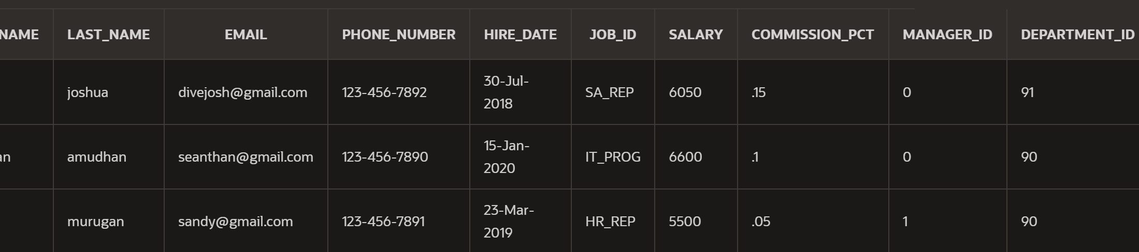

## 5.6:

DECLARE

CURSOR cur_dept IS

SELECT department_id, department_name

FROM department1;

CURSOR cur_emp(p_deptid NUMBER) IS

SELECT last_name, first_name

FROM employee3

WHERE department_id = p_deptid;

v_deptrec cur_dept%ROWTYPE;

v_emprec cur_emp%ROWTYPE;

BEGIN

OPEN cur_dept;

LOOP

FETCH cur_dept INTO v_deptrec;

EXIT WHEN cur_dept%NOTFOUND;

DBMS_OUTPUT.PUT_LINE(v_deptrec.department_name);

OPEN cur_emp(v_deptrec.department_id);

LOOP

FETCH cur_emp INTO v_emprec;

EXIT WHEN cur_emp%NOTFOUND;

DBMS_OUTPUT.PUT_LINE(v_emprec.last_name || ', ' || v_emprec.first_name);

END LOOP;

CLOSE cur_emp;

END LOOP;

CLOSE cur_dept;

END;

**OUTPUT:**

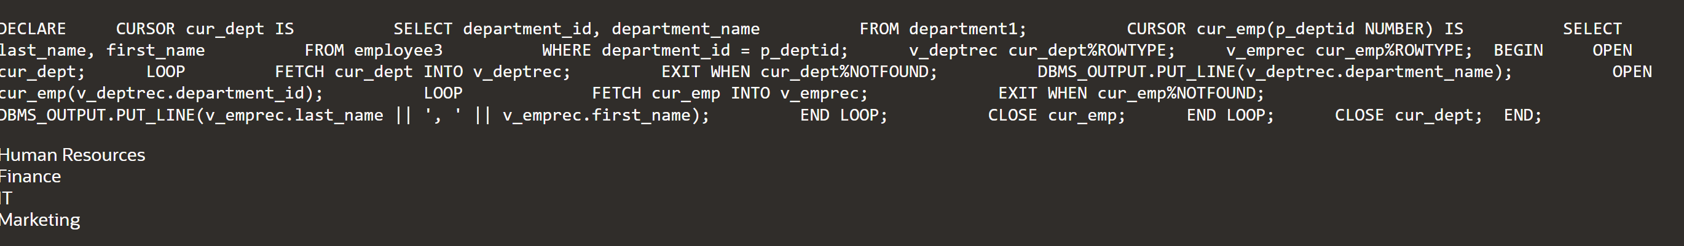

**USING FOR LOOP WITH MULTIPLE CURSORS:**

**Laction table:**



**Department table:**



DECLARE

CURSOR cur_loc IS

SELECT * FROM locations;

CURSOR cur_dept(p_locid NUMBER) IS

SELECT * FROM department2 WHERE location_id = p_locid;

BEGIN

FOR v_locrec IN cur_loc LOOP

DBMS_OUTPUT.PUT_LINE(v_locrec.city);

FOR v_deptrec IN cur_dept(v_locrec.location_id) LOOP

DBMS_OUTPUT.PUT_LINE(v_deptrec.department_name);

END LOOP;

END LOOP;

END;

**Output:**

